**IM3080 Design and Innovation Project (AY20xx/xx Semester x)**

**Individual Report**

Name: Leow Siew Ting

Group No: _______7___________

Project Title: _____joiNTU_________

**Contributions to the Project** (1-2 page)

During the initial brainstorming process, everyone came up with ideas for the project. Our group finally settled on working on a supermarket app. The app we chose to work on was the cold storage app. However, after hearing feedbacks from the professors on week 3, our group decided to change the idea completely as we felt it was not feasible in the long run.

Thus, we decided on joiNTU, a mobile application designed to help students in their daily lives in NTU. We were split into 3 sub-teams Design, Coding 1, and Coding 2 to ease communication with each other. I was assigned into Coding 2 team where we worked on the different functions of “WorkSpace”.

I worked on the Uploading and Retrieving of pdf and images function with one of my groupmates Jia Jun. As we are all unfamiliar with Firebase, we had to take some time to understand how firebase works and how our data is stored in it to be able to upload and retrieved it into our application. Between the two of us I was in-charge of the uploading part. The process was not smooth sailing, however after much researching and debugging, we managed to get the function to work.

Subsequently, I was assigned to do up the UI/UX of the “WorkSpace”. For the UI/UX I have to replicate the exact same design the design team came out with on Figma onto Android Studio. I also do up the Pop-up function in the app that allowed the user to invoke the upload functions by pressing a button in the app. To make the app standardized, we have a fixed group of colors and fonts style that we use for the app. However, during the process, I faced some difficulties such as not being able to implement some of the elements and pictures onto Android Studio. This is either caused by the file size of the image being too big or the file type being different.

After finalizing the UI/UX, I was moved to the video team together with Zhao Sheng and Kai Li to help out with the production of our short clip. After hearing everyone’s suggestions and ideas for the video, the video team worked towards the direction the team want the video to look like. I was in charge of storyboarding as well as the scriptwriting for the video. I needed to ensure that the length of lines matches all the different scenes so that it will not overrun the time frame for the video.

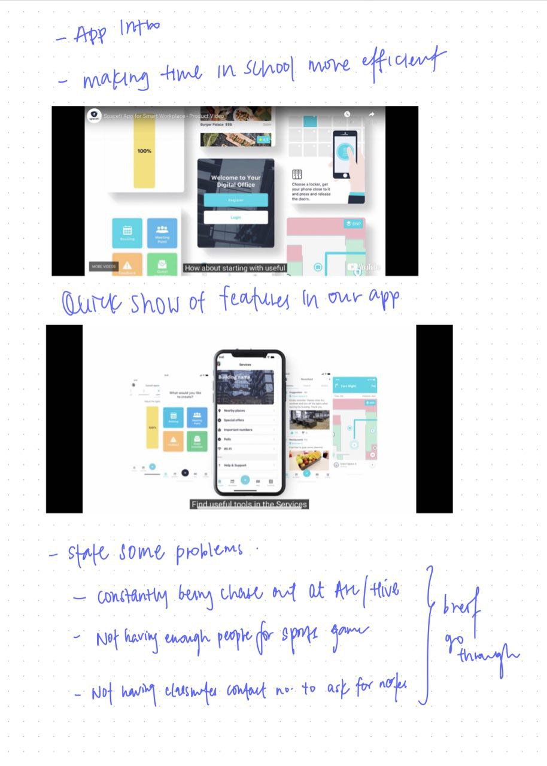

Video Storyboard

Furthermore, I was assigned to do the presentation in week 3 and 14. For week 3, I presented our initial idea which is a supermarket app and the different functions we wanted to implement as well as the time planned for this whole project. While on week 14, it will be our final presentation and I did the slides for the presentation that showcases our application as a whole. The content of the presentation were done together as a team, leaving the design of the slides to the people that is going to present.

**Reflection on Learning Outcome Attainment**

**Reflect on your experience during your project and the achievements you have relating to at least two of the points below:**

1. Engineering knowledge
2. Problem Analysis
3. Investigation
4. Design/development of Solutions
5. Modern Tool Usage
6. The Engineer and Society
7. Environment and Sustainability
8. Ethics
9. Individual and Team Work
10. Communication
11. Project Management and Finance
12. Lifelong Learning

Point 1: ___J__ State the area: Teamwork relies heavily on communication, as without it we have no way of knowing what each person has done or the progress of the project. Especially when your project is made of 11 people from different backgrounds getting assigned together to, make communications even more important. For example, at the start of working on the project we have to ensure that everyone is clear and informed about their roles and responsibilities. As problems and projects come as a package, in any project there will definitely be problems and problems will normally result in delay in the project. In order to prevent things mentioned to happen, we split ourselves into different sub- groups such as Design, Booking, Workspace teams. With that we will be able to ease communications between each other and avoid incidents like miscommunication or misunderstanding to happen.

Point 2: ___B__ State the area: Some of the functions in our app overlapped each other. Hence when we want save time and modify the code done by other members to make it fit into the functions I am working on, will always result in a lot of errors, resulting my whole program will not be able to run and eventually crash. In order to recover my work, I have to debug the errors. Normally, I will google the error first in order to understand what it is about. If after googling I still do not understand then I will contact my teammate and we discuss the solution together. Sometimes is due to the missing implementation in gradle or maybe they added or change some elements that I did not realize causing the error.